# Introduction

This documents various projects and research efforts in the Autonomous Flight Systems Laboratory ([AFSL](http://www.aa.washington.edu/research/afsl/)) at the University of Washington ([UW](http://www.washington.edu/)).

# Current Research Efforts

## Flight Operations Infrastructure for UAS Research

The UW AFSL conducts flight operations and experiments both domestically and internationally (Figure 1). The purpose of these operations are to support research and education related to unmanned aerial systems (UAS). To support these activities, the UW AFSL has established infrastructure to allow safe, legal, and efficient flight operations. Some examples of this infrastructure include obtaining FAA blanket Certificates of Authorization or Waiver (COAs), filing of Section 333 exemption petitions, retaining part 61 certificated pilots, establishing protocols to be in compliance with part 107 (the sUAS rule), and construction of a Mobile Flight Operations Center (MFOC) (Figure 2).

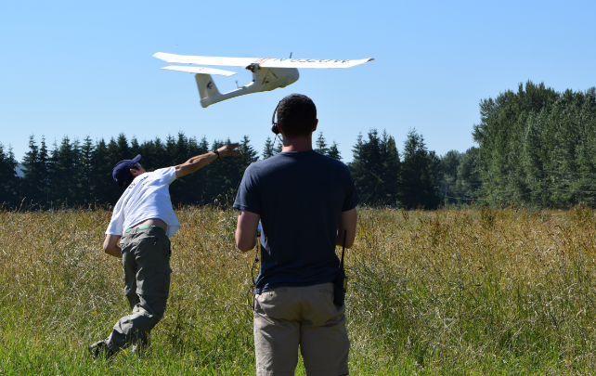

Figure 1: Flight operations conducted near North Bend, WA under COA 2016-WSA-23-COA

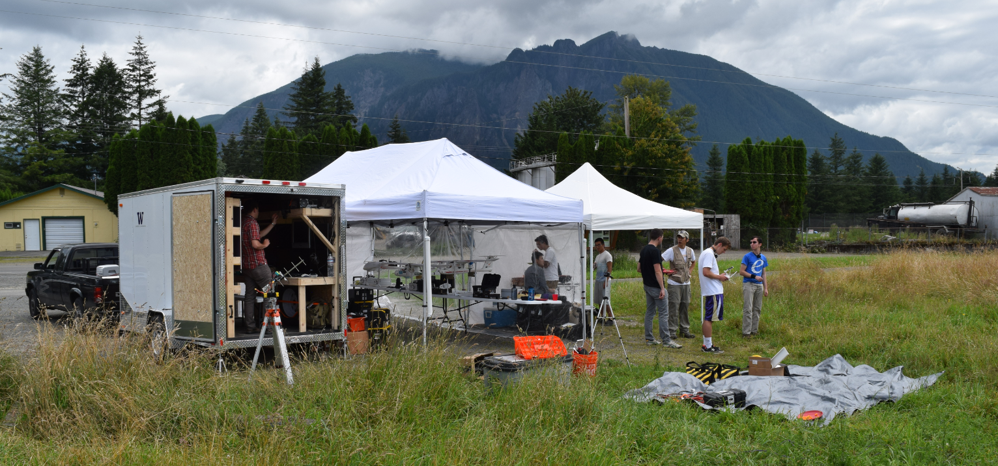

Figure 2: Mobile flight operations infrastructure allowing deployment and data collection at remote locations.

## Visual Anchoring

UAS are becoming increasingly popular and their size, payload, and applications vary widely. These systems range from airliner-sized [RQ-4 Global Hawk](http://en.wikipedia.org/wiki/Northrop_Grumman_RQ-4_Global_Hawk) aircraft to biologically-inspired, insect-like [ornithopters](http://en.wikipedia.org/wiki/DelFly). One can find UAS suitable for an equally large range of missions, such as high altitude surveillance, tactical orbit coordination [1], and formation flight [2]. Although these systems and missions seem dissimilar, the unifying technology on which all rely is a Global Positioning System (GPS). Without GPS, nearly all of these systems become inoperable or severely handicapped. With [GPS jamming](http://www.gps.gov/spectrum/jamming/) devices [widely and inexpensively available](http://www.foxnews.com/tech/2010/03/17/gps-jammers-easily-accessible-potentially-dangerous-risk/), this single-point-of-failure represents a significant weakness in the capabilities and robustness of UAS. The proposed work focuses on developing navigation techniques and control algorithms to allow UAS to operate in GPS-denied environments. The system will use vision based sensors (such as [pan/tilt/zoom video cameras](http://www.hoodtechvision.com/doc/HoodTech_05EO1_Spec_Sheet24JAN14.pdf)) and combine visual information with data from other sensors to enable basic navigation and operation in the absence of GPS as shown in Figure 3.

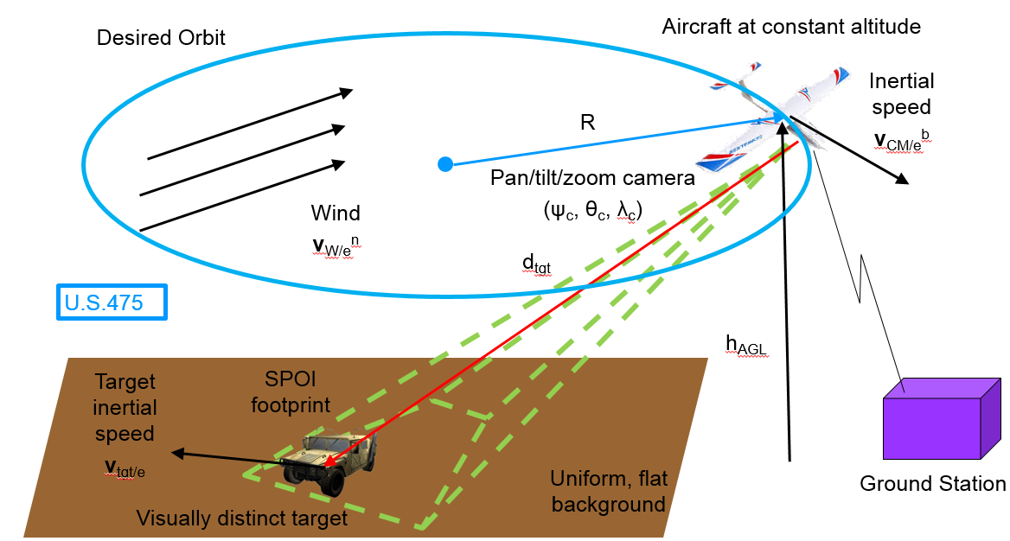

Figure 3: Stabilizing an orbit of a UAS around a visually distinct target in GPS denied environments.

## Integration of NextGen Technologies on UAS for Enhanced Situational Awareness in GPS-Denied Environments

UAS integration into the US marketplace has been stymied by slow government regulatory changes. The Federal Aviation Administration (FAA) Modernization and Reform Act of 2012 [3] outlines steps forward on many aviation fronts to bring aerospace into the modern era. One major initiative from this act is the mandated safe [integration of UAS into the National Airspace System](http://www.faa.gov/news/updates/?newsId=68004) (NAS). Another related initiative is the FAA’s Next Generation Air Transportation System ([NextGen](http://www.faa.gov/nextgen/)) [4] which showcases the Automatic Dependent Surveillance-Broadcast ([ADS-B](http://www.faa.gov/nextgen/programs/adsb/)) system as being a key component for both manned and unmanned traffic. However, a recent investigation by the US Department of Transportation Inspector General’s Office [5] [specifically identified](https://www.oig.dot.gov/library-item/28822) these two areas as behind schedule and in need of additional development. ADS-B relies heavily on availability of the Global Positioning System ([GPS](http://en.wikipedia.org/wiki/Gps)) and cannot function properly without reliable GPS. This project proposes a system to maintain aircraft tracking and situational awareness in the event of loss of GPS by a UAS. This proposal focuses on developing both hardware and software components necessary to perform seamless UAS operations and monitoring in GPS-denied environments. The envisioned architecture for nominal and GPS-denied operations is shown in Figure 4.

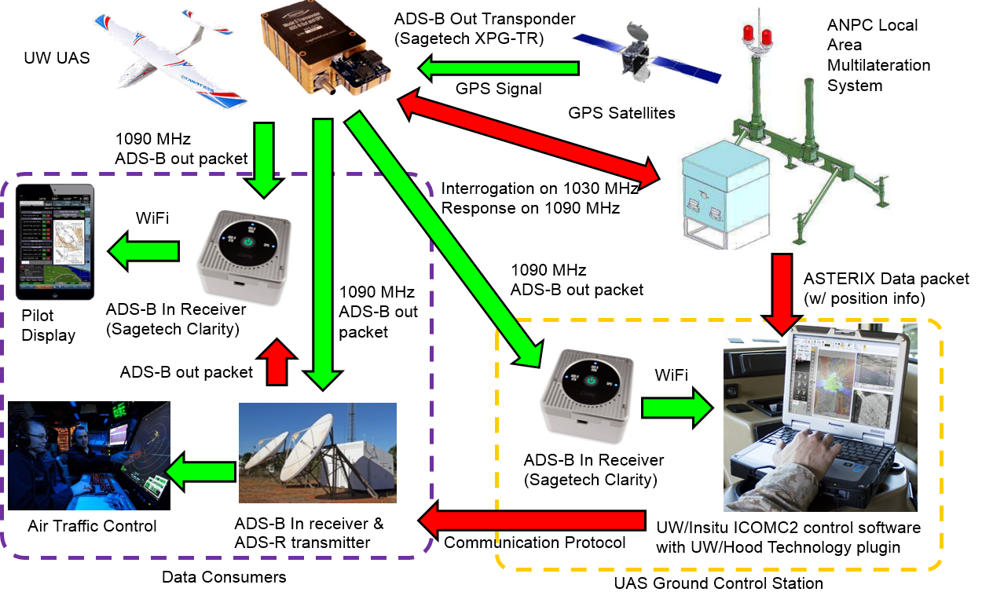

Figure 4: Architecture for nominal (green pathways) and GPS-denied (red pathways) operations.

In a nominal operational scenario (green arrows), the UAV equipped with an ADS-B out transponder ([Sagetech XPG-TR](http://www.sagetechcorp.com/unmanned-solutions/unmanned-solutions.cfm#.VN48_Y10yfA)) is able to determine its position and velocity from available GPS-signals. By combining information from a static pressure transducer (for altitude measurement), the UAV is able to broadcast ADS-B out packets on the 1090 MHz channel at 2 Hz. This information is received by any ADS-B in receiver in range. For example, the UAS operator and a general aviation (GA) aircraft (both equipped with a [Sagetech Clarity](http://www.sagetechcorp.com/general-aviation-solutions/clarity-ads-b.cfm#.VN4_mY10yfA) receiver) will directly receive position information about the UAV. Simultaneously, air traffic control (ATC) will receive these messages via the appropriate ADS-B in receiver. In the nominal scenario, all relevant stakeholders are able to maintain situational awareness with respect to all traffic in the operational airspace.

If the UAV enters a GPS-denied environment, the ADS-B out transponder on the UAV will revert to a standard mode S transponder. It no longer broadcasts ADS-B out messages and will therefore become invisible to the ADS-B in receivers on the ground. The UAV position can still be obtained via secondary surveillance radar ([SSR](http://en.wikipedia.org/wiki/Secondary_surveillance_radar)) although these are prohibitively expensive, deliver very-low update rates and are impractical to deploy in some areas. This proposal focuses on the use of the [ANPC](http://www.anpc.com/) Local Area Multilateration System ([LAMS](http://www.anpc.com/aircraft-surveillance/)) alternative system to replace the functionality of SSR. This proposed alternative signal flow is shown in Figure 4 as red arrows. In this scenario, the LAMS interrogates the transponder on 1030 MHz and receives only aircraft ID information on 1090 MHz (recall that the aircraft is in a GPS-denied environment and is therefore unable to localize itself). Using information from the responding signal (such as time of arrival, difference time of arrival, and angle of arrival), the LAMS can determine position information of the UAV. This information can be combined with altitude (from the received transponder message) and exported as an All Purpose Structured Eurocontrol Surveillance Information Exchange ([ASTERIX](http://en.wikipedia.org/wiki/ASTERIX_(ATC_standard))) Category [34](http://www.eurocontrol.int/sites/default/files/content/documents/nm/asterix/cat034-asterix-monoradar-service-messages-part-2b-next-version-of-cat-002.pdf) and [48](http://www.eurocontrol.int/sites/default/files/content/documents/nm/asterix/cat048-asterix-appendix-a-v1.7-20140901.pdf) messages suitable for consumption by ATC or by the UAS ground control station ([GCS](http://en.wikipedia.org/wiki/Ground_control_station)). The ASTERIX data packets from the LAMS will be consumed by a GCS with the Insitu Common Open-mission management Command and Control ([ICOMC2](http://www.insitu.com/systems/icomc2)) software. The system will contain a software plugin developed by UW and Hood Technology to display relevant information on the GCS to allow the operator to maintain situational awareness with respect to the UAV position even though the aircraft is unable to ascertain its own position. This information can also be routed to ATC so they can determine the location of the UAV. ATC can then relay these messages to other aircraft via ADS-B out packets. In this fashion, all aviation stakeholders maintain situational awareness even though the UAV is in a GPS-denied environment. This system will support up to 300 transponder equipped aircraft within a 60 nautical mile radius. A major component of the project will involve integrating these separate technologies into a cohesive tracking system at the UAS test area.

## Applications of Imagery from Aerial Platforms

The UW AFSL has applied various UAS for aerial mapping. These system utilize both electro-optical (EO) and multi-spectral cameras to obtain aerial photos of a given survey site. Traditional analysis utilizes normalized difference vegetation index (NDVI) maps to assess crop health and vigor. Vegetation status and growth can be determined from NDVI maps while elevation data is gathered from digital surface model (DSM) maps.

Research at the AFSL is investigating the possibility of using this information to perform environmental change detection. Combining both EO and NDVI maps may allow researchers to identify features such as newly forged trails in a field (Figure 6). This technology has applications to anti-poaching and invasive species monitoring and detection.

|  |  |
| --- | --- |
|  |  |

Figure 5: NDVI map on the left and DSM map on the right.

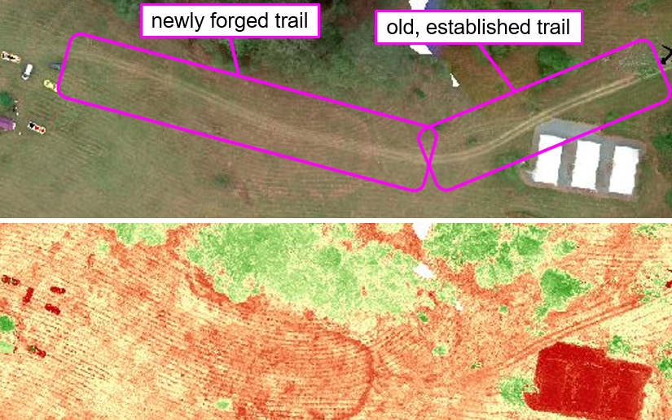

Figure 6: Aerial survey of a farm in Brisbane, Australia showing how EO and NDVI maps can be used to identify new trails/roads in an environment.

# Past Research

## Risk Assessment of UAS Operations over Populated Environments

See [6] and [7].

## Autonomous Search Using Team of Heterogeneous Autonomous Agents

See [8], [9], [10], [11], [12], [13], [14], and [15]

## Formation Flight of Swarms of UAS

See [1] and [16]

# References

|  |  |
| --- | --- |
| [1] | R. T. Rysdyk, C. W. Lum and J. Vagners, "Autonomous Orbit Coordination for Two Unmanned Aerial Vehicles," 2005. |
| [2] | C. Lum, J. Vagners, M. Vavrina and J. Vian, "Formation Flight of Swarms of Autonomous Vehicles In Obstructed Environments Using Vector Field Navigation," 2012. |
| [3] | United States Superintendent of Documents, "FAA Modernization and Reform Act of 2012," United States Government Printing Office, 2012. |
| [4] | Federal Aviation Administration, "NextGen UAS Research, Development and Demonstration Roadmap," 2012. |
| [5] | Scovel, Calvin L;, "FAA's Implementation of the FAA Modernization and Reform Act of 2012 Remains Incomplete," Department of Transportation Inspector General, 2014. |
| [6] | C. W. Lum and B. Waggoner, "A Risk Based Paradigm and Model for Unmanned Aerial Systems in the National Airspace," in *Proceedings of the AIAA Infotech@Aerospace Conference*, St. Louis, 2011. |
| [7] | C. W. Lum, K. R. Gauksheim, T. Kosel and T. McGeer, "Assessing and Estimating Risk of Operating Unmanned Aerial Systems in Populated Areas," in *Proceedings of the AIAA Aviation Technology, Integration, and Operations Conference*, Virginia Beach, 2011. |
| [8] | C. W. Lum, "Coordinated Searching and Target Identification Using Teams of Autonomous Agents," University of Washington, Seattle, 2009. |
| [9] | C. W. Lum and R. T. Rysdyk, "Time Constrained Randomized Path Planning Using Spatial Networks," in *Proceedings of the IEEE American Control Conference*, Seattle, 2008. |
| [10] | C. W. Lum and R. T. Rysdyk, "Feature Extraction of Low Dimensional Sensor Returns for Autonomous Target Identification," in *Proceedings of the AIAA Guidance, Navigation, and Control Conference*, Honolulu, 2008. |
| [11] | C. W. Lum and J. Vagners, "A Modular Algorithm for Exhaustive Map Searching Using Occupancy Based Maps," in *Proceedings of the AIAA Infotech@Aerospace Conference*, Seattle, 2009. |
| [12] | C. W. Lum, M. L. Rowland and R. T. Rysdyk, "Human-in-the-Loop Distributed Simulation and Validation of Strategic Autonomous Algorithms," in *Proceedings of the AIAA Aerodynamic Measurement Technology and Ground Testing Conference*, Seattle, 2008. |
| [13] | C. W. Lum, J. Vagners and R. T. Rysdyk, "Search Algorithms for Teams of Heterogeneous Agents with Coverage Guarantees," *AIAA Journal of Aerospace Computing, Information, and Communication,* vol. 7, no. 1, pp. 1-31, 2010. |
| [14] | C. W. Lum, R. T. Rysdyk and A. Pongpunwattana, "Autonomous Airborne Geomagnetic Surveying and Target Identification," in *Proceedings of the AIAA Infotech@Aerospace Conference*, Arlington, 2005. |
| [15] | C. W. Lum, R. T. Rysdyk and A. Pongpunwattana, "Occupancy Based Map Searching Using Heterogeneous Teams of Autonomous Vehicles," in *Proceedings of the AIAA Guidance, Navigation, and Control Conference*, Keystone, 2006. |
| [16] | C. W. Lum, J. Vagners, M. Vavrina and J. Vian, "Formation Flight of Swarms of Autonomous Vehicles In Obstructed Environments Using Vector Field Navigation," in *Proceedings of the International Conference on Unmanned Aircraft Systems*, 2012. |
| [17] | C. W. Lum, A. Summers, B. Carpenter, A. Rodriguez and M. Dunbabin, "Automatic Wildfire Detection and Simulation Using Optical Information from Unmanned Aerial Systems," in *Proceedings of the 2015 SAE Aerotec Conference*, Seattle, 2015. |
| [18] | C. W. Lum, S. Gardner, C. Jordan and M. Dunbabin, "Expanding Diversity in STEM: Developing International Education and Research Partnerships in a Global Society," in *Proceedings of the American Society for Engineering Education 123rd Annual Conference & Exposition*, New Orleans, 2016. |
| [19] | C. W. Lum, M. MacKenzie, C. Shaw-Feather, E. Luker and M. Dunbabin, "Multispectral Imaging and Elevation Mapping from an Unmanned Aerial System for Precision Agriculture Applications," in *Proceedings of the 13th International Conference on Precision Agriculture*, St. Louis, 2016. |
| [20] | C. W. Lum, J. Vagners, J.-S. Jang and J. Vian, "Partioned Searching and Deconfliction: Analysis and Flight Tests," in *Proceedings of the IEEE American Control Conference*, Seattle, 2010. |
| [21] | C. W. Lum and R. T. Rysdyk, "Rapid Verification and Validation of Strategic Autonomous Algorithms Using Human-in-the-Loop Architectures," University of Washington Autonomous Flight Systems Laboratory, Seattle, WA, 2008. |